Data Modelling and Form Design

Aim
To design and develop a Bank Loan Application Form using Zoho Creator by creating a structured form, applying appropriate validations, and generating a report for managing loan applications.

Theory
Data modelling and form design involve organizing data into suitable fields and sections for efficient collection and management. In Zoho Creator, forms can be created using different field types such as Name, Email, Address, Phone, Single Line, Multi Line, Number, Date, Time, Drop Down, Radio, Multi Select, and Checkbox.
In this experiment, a Loan_Application_Form is designed to collect applicant details, contact information,
employment and income details, loan requirements, existing liabilities, and credit-check consent. The form is divided into four sections: Personal Details, Contact Details, Income & Employment Details, and Loan Details & Consent.

Validations are applied to ensure accurate data entry, including mandatory fields, valid email and phone formats, positive income values, minimum age of 18 years, and compulsory credit-check consent. The submitted data is
displayed in the Loan_Application_Report for review and pre-screening.

Procedure
- Open Zoho Creator and create the Loan Application & Pre-Screening Management application.
- Create the Loan_Application_Form.
- Add the required fields for applicant, contact, employment, income, loan, and consent details.
- Organize the fields into the four specified sections.
- Configure mandatory fields and apply the required validation rules.
- Save and preview the form.
- Enter sample applicant details and submit the form.
- Create the Loan_Application_Report and verify the submitted records.
- Filter the records based on loan type and monthly income for pre-screening.
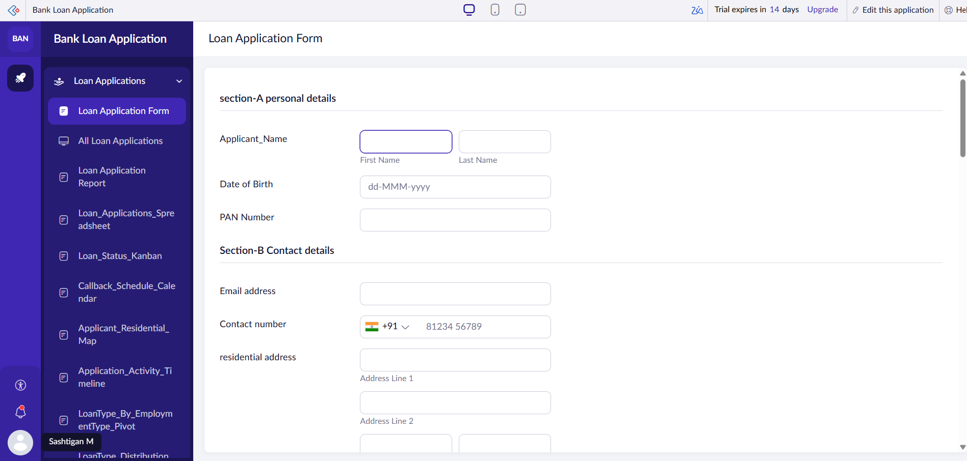

Sreenshots:

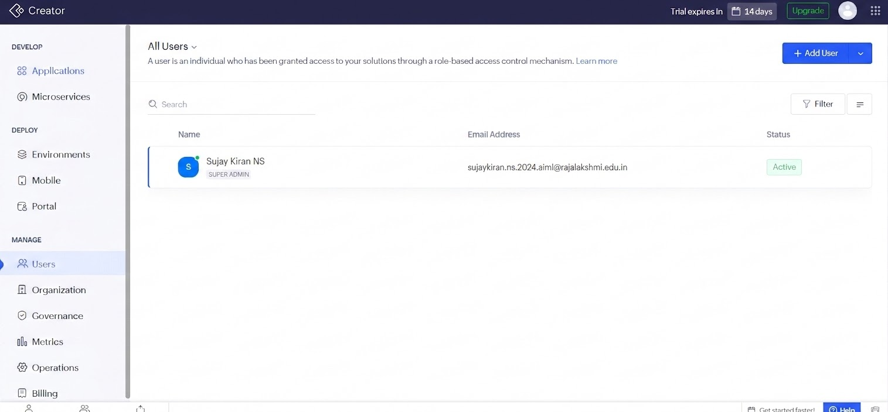
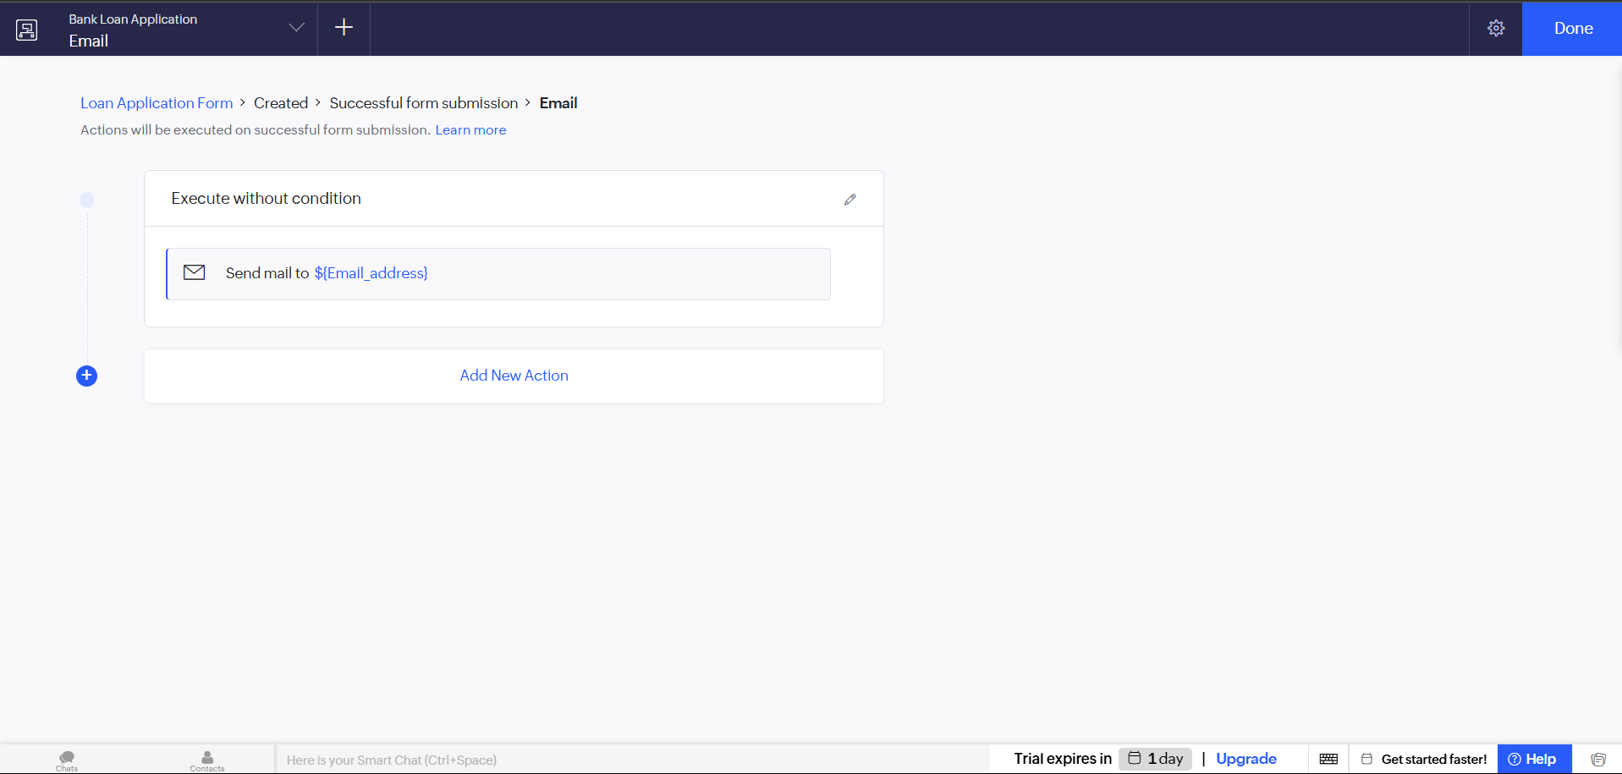

Result
The Bank Loan Application Form was successfully created in Zoho Creator with a structured data model, appropriate field validations, and organized sections. The submitted applications were successfully stored and displayed in
the Loan_Application_Report for effective review and pre-screening.

